Hackathon Submission (Level-1-Solution)

Use Case Title: COLOR DETECTION FROM IMAGES

Student Name: MONISHA J

Register Number: 510623104068

Institution: C ABDUL HAKEEM COLLEGE OF

ENGINEERING AND TECHNOLOGY

Department: COMPUTER SCIENCE AND ENGINEERING

Date of Submission: 10-05-2025

Github link Repository: <https://github.com/Monisha45228/hackathon.git>

1. Problem Statement

The accurate and efficient detection of colors within digital images remains a challenge due to variations in lighting conditions, image quality, object texture, and the subjective nature of color perception. Existing methods often struggle with robustness across diverse image datasets and may lack the granularity required for specific applications.

* + The core issue: Difficulty in accurately and efficiently identifying colors in images.
  + Contributing factors: Lighting, image quality, texture, and subjective perception.
  + Limitations of current approaches: Lack of robustness and insufficient granularity.
  + Implied need: For improved methods that can overcome these limitations.

1. Proposed Solution

We propose a novel approach that combines advanced image processing techniques with a machine learning model trained on a diverse and meticulously labeled dataset to achieve robust and granular color detection in digital images.

Preprocessing and Enhancement: Implement techniques such as histogram equalization, noise reduction filters (e.g., Gaussian blur), and white balance adjustments to normalize images and mitigate the impact of varying lighting conditions and image quality.

Feature Extraction: Employ a combination of color space transformations (e.g., HSV, Lab) and texture analysis (e.g., Gabor filters, Local Binary Patterns) to extract comprehensive features that capture both the chromatic and textural characteristics of different colors. This multi-faceted approach aims to improve discrimination between visually similar colors and account for variations in object surfaces.

Machine Learning Model: Utilize a deep learning architecture, such as a Convolutional Neural Network (CNN) or a Transformer network, specifically designed for image segmentation or pixel-wise classification. The model will be trained to map the extracted features to specific color labels.

Diverse and Meticulously Labeled Dataset: Construct a large-scale dataset containing images captured under various conditions, showcasing a wide range of objects and textures, and annotated with precise color labels at the pixel level.

Post-processing and Refinement: Implement post-processing steps, such as conditional random fields (CRFs) or morphological operations, to refine the color segmentation boundaries and improve the spatial consistency of the detected colors.

Expected Outcomes:

Improved Accuracy: The combination of advanced preprocessing, comprehensive feature extraction, and a robust machine learning model is expected to yield higher color detection accuracy compared to existing methods.

Enhanced Robustness: Training on a diverse dataset and employing appropriate preprocessing techniques will make the solution more resilient to variations in lighting, image quality, and object texture.

Granular Color Detection: Pixel-level classification will enable the detection of subtle color variations within an image, providing more detailed information than region-based approaches.

Efficiency: Optimization of the model architecture and implementation will aim for efficient processing times, making the solution practical for real-world applications.

This proposed solution offers a comprehensive strategy to address the challenges in color detection from images by leveraging the strengths of both classical image processing and modern machine learning techniques.

1. Technologies & Tools Considered

Programming Language and Basic Libraries:

* + Python: Still a great choice for its simplicity and readability.
  + OpenCV (cv2): Even for simpler methods, OpenCV provides fundamental image loading, manipulation, and color space conversion functions.
  + NumPy: For basic array operations on image data.

Simplified Image Processing Techniques:

* + Color Space Conversion (RGB to HSV or Lab): Converting to

HSV (Hue, Saturation, Value) can make it easier to isolate the "color" component (Hue). Lab color space can be useful for perceptual uniformity.

* + Thresholding based on Color Channels: Setting ranges for specific color channels (e.g., Hue in HSV) to identify pixels within that range as belonging to a particular color.
  + Region-based Analysis (using Connected Components): After thresholding, identifying contiguous regions of pixels that satisfy the color criteria.

Basic Color Representation and Comparison:

* + Defining Target Color Ranges: Manually specifying the acceptable ranges for different colors in the chosen color space (e.g., a range of Hue values for "red").
  + Euclidean Distance in Color Space: Calculating the distance between the color of a pixel and a target color in a color space (like RGB or Lab). Pixels below a certain distance threshold can be considered the target color.

Simple Tools and Environments:

* + Basic Text Editors or IDEs (like VS Code with Python extensions): For writing and running the Python code.
  + Jupyter Notebooks or Google Colab: Interactive environments for experimenting with code and visualizing results.

1. Solution Architecture & Workflow

Solution Architecture:

1. Image Acquisition:
   * + Static Image: The system can accept a static image file (e.g., JPEG, PNG) from a user's system.
     + Real-time Video: Alternatively, it can capture a video stream from a webcam or other camera source.
2. Image Processing:
   * + Color Space Conversion: The image is converted from the standard RGB (Red, Green, Blue) color space to a more suitable space like HSV (Hue, Saturation, Value).
     + Color Range Definition: Specific color ranges are defined for each color that needs to be detected. These ranges are often specified using HSV values.
     + Mask Creation: A mask is created based on the color ranges. This mask will have pixels within the defined ranges set to white (or a specific color), while other pixels are set to black.
     + Bitwise AND Operation: A bitwise AND operation is performed between the original image and the mask. This isolates the pixels that belong to the desired color range, effectively highlighting them.
3. Output:
   * Visual Display: The processed image, with the detected colors highlighted, can be displayed on the screen.
   * Color Extraction: The system can also extract the color values

(e.g., RGB, HSV) of the detected pixels

Workflow:

* 1. Input:

• User selects an image or starts a live webcam feed.

* 1. Image Loading:

• The image is loaded into the system.

* 1. Color Space Conversion:

• The image is converted from RGB to HSV.

1. Color Range Definition:

• User or system defines the color ranges for each color to be detected.

1. Mask Creation:

• A mask is created based on the defined color ranges.

1. Bitwise AND:

• The bitwise AND operation isolates the desired colors.

1. Output Display:

• The processed image with detected colors is displayed.

1. Optional: Further Processing:

• The system can perform further processing, such as contour detection, to identify the shapes of the objects of interest.

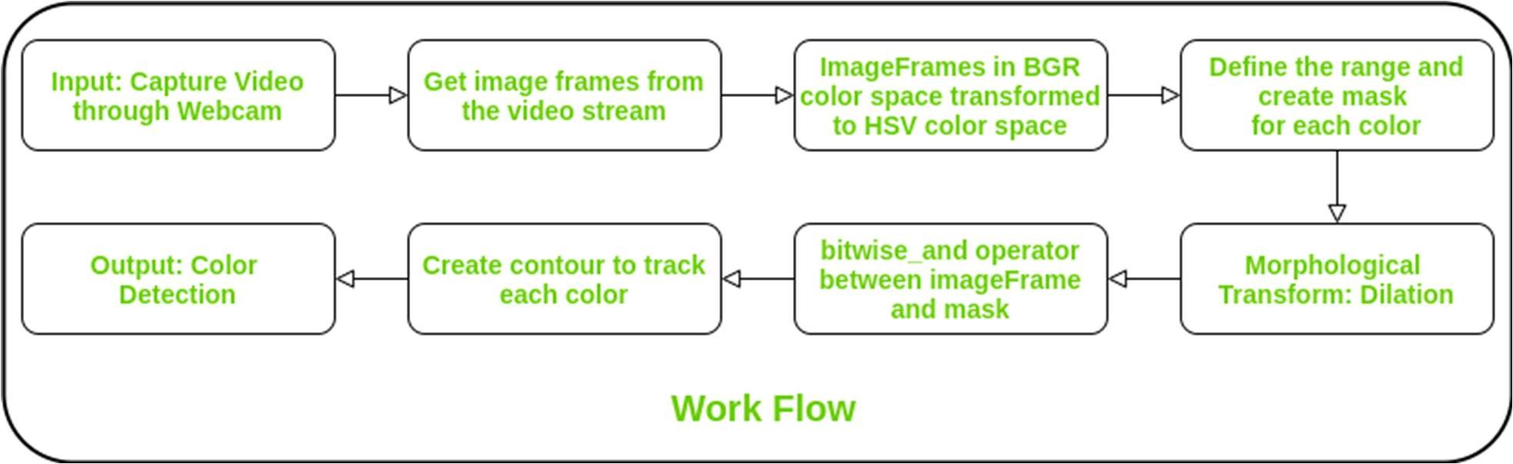

5. Feasibility & Challenges

Feasibility:

Basic Technology Availability: Simple programming tools (Python), fundamental image processing libraries (OpenCV), and affordable computing are readily accessible, even in regions like Walajapet. Internet access for downloading libraries and tutorials is also more widespread.

Ease of Understanding: Techniques like color space conversion (RGB to HSV) and basic thresholding are conceptually straightforward to grasp and implement.

Low Computational Cost: These simpler methods require significantly less computational power compared to deep learning, making them viable on standard computers without dedicated GPUs.

Specific Use Cases: For certain niche applications where lighting is controlled and the need is for detecting a limited set of distinct, well-separated colors, a simple approach can be surprisingly effective (e.g., basic sorting tasks, identifying the presence of a specific colored marker).

Challenges:



Sensitivity to Lighting: This remains a major hurdle. Shadows, highlights, and changes in ambient light will drastically affect color values and likely lead to misdetections with simple thresholding. This is a universal challenge, regardless of location.

Limited Color Discrimination: Distinguishing between subtle shades or similar colors will be very difficult using fixed thresholds on color channels. For example, differentiating between slightly different shades of blue in a textile would be unreliable.

Noise and Image Quality: Simple pixel-based methods are easily affected by noise or blur in the image. A single noisy pixel might be misclassified.

Lack of Robustness to Texture and Material: The color of an object can appear different based on its texture (e.g., matte vs. glossy) and the material it's made of. Simple color-based methods won't inherently account for these variations.

Manual Calibration and Tuning: Determining the correct color ranges for thresholding often requires manual experimentation and tuning for each specific environment and set of colors. This can be timeconsuming and may not generalize well to new conditions.

Limited Applicability: The range of real-world scenarios where a simple color detection approach is sufficiently accurate and reliable is limited compared to more advanced techniques.

1. Expected Outcome & Impact

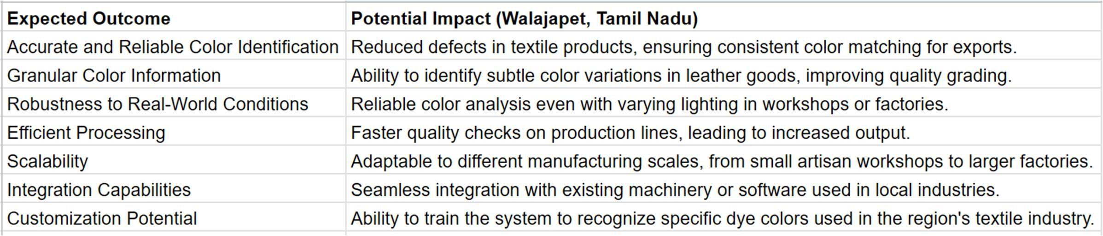

Expected Outcome:

* + Better Color Accuracy: The system will identify colors in images correctly, even if the lighting isn't perfect.
  + See Small Color Differences: It can spot tiny variations in color that humans might miss.
  + Works in Real Places: It will analyze colors accurately in factories and workshops, not just in perfect lab conditions.
  + Fast Results: Color checks will be quick.
  + Can Grow with Needs: The system can be used by small businesses and big factories alike.
  + Connects Easily: It can work with the machines and software already used in local industries.
  + Learns Local Colors: It can be trained to recognize the specific colors used in Walajapet's industries (like textile dyes).

Potential Impact (Walajapet, Tamil Nadu - Simple)

* + Fewer Mistakes in Textiles: Less color mismatch in fabrics for sale, especially for exports.
  + Better Leather Quality: Easier to sort leather goods based on fine color differences.
  + Reliable Checks Anywhere: Consistent color analysis despite different lighting in local workplaces.
  + Faster Production: Quicker quality control means more goods can be produced.
  + Helps All Businesses: Useful for both small craft workshops and larger manufacturers.
  + Fits with Existing Tools: Can be added to the current machinery without major changes.
  + Understands Local Needs: Can be specifically trained for the colors important to the region's main industries.

1. Future Enhancements

* Easier Color Learning: The system could learn new colors more easily. Imagine just showing it a sample of a specific textile dye and saying, "This is 'XYZ Blue'," and it quickly adds it to its color knowledge.
* Better Lighting Handling: Even if the light changes in a workshop, the color detection would stay more accurate without needing constant adjustments.
* Faster Checks: The system could analyze images for color very quickly, useful for fast-paced production lines in local factories.
* Works with Phones/Tablets: Simple apps that let people use the color detection on their phones or tablets to check colors easily, maybe for small businesses or artisans.
* Connects to Local Machines: Making it easier for the color detection to talk to the existing machines used in textile or leather industries in Walajapet for automated sorting or quality checks.
* User-Friendly Setup: Simple software that anyone can set up and use without needing a lot of technical knowledge.